**Lead One**

**Police Brutality**

**STRAP**

**Ecowas Court Holds Salone Accountable for Multiple Human Rights Violation**

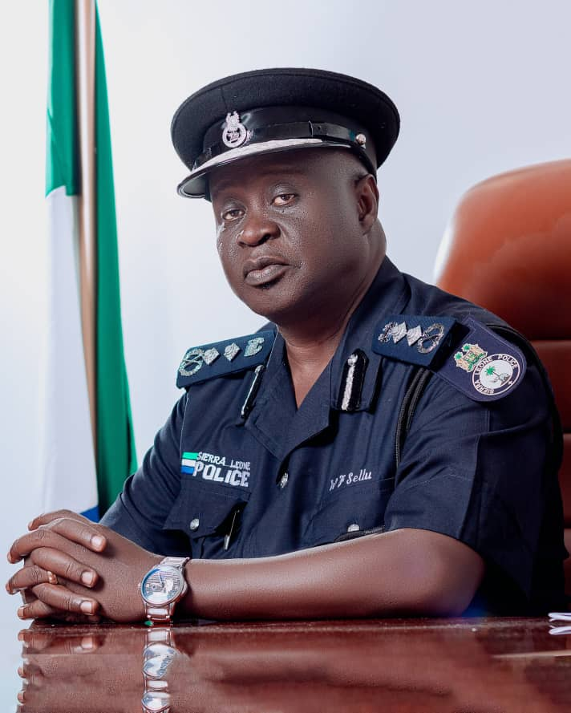

***William Fayia Sellu, Inspector General Sierra Leone Police***

Advocaid and the Institute for Human Rights Development in Africa (IHRDA) are pleased to celebrate a pivotal judgment by the Economic Community of West African States (ECOWAS) Community Court of Justice in the "Mohamed Morlu v. Republic of Sierra Leone" case.

The court held Sierra Leone accountable for violating multiple rights under the African Charter on Human and Peoples' Rights, the International Covenant on Civil and Political Rights, and the Convention Against Torture (CAT).

Consequently, Sierra Leone has been ordered to compensate Mr. Morlu, marking a significant stride in the battle for police accountability and setting a crucial precedent for defining torture in the context of protests.

Mr. Morlu filed the case in August 2022 with the backing of Advocaid and IHRDA, asserting that Sierra Leone breached his rights to personal security and freedom from torture. These violations occurred when police shot him in the abdomen during a peaceful student protest in Bo in March 2017. The state further infringed on his right to a remedy by failing to effectively investigate and prosecute those responsible for the shooting.

In response to the judgment, Mr. Morlu expressed his relief, stating, "After seven years of living with the echoes of this painful incident with no one being held responsible, I am relieved and grateful for the ECOWAS Court's decision. This victory gives hope to other victims of police brutality that justice is attainable."

Eleanor Thompson, legal counsel for Mr. Morlu, highlighted the broader significance of the case, stating, "This case wasn't just about redressing the harm caused to Mr. Morlu; it aimed to remind the state of its obligations under numerous international human rights treaties that it has ratified while assessing systemic failures in law enforcement practices."

Advocaid Executive Director, Ms. Alison French, praised the ECOWAS Court's decision, affirming, "This judgment reaffirms the principle that no one is above the law, including law enforcement agencies. It sends a clear message that police violence and misconduct will not be tolerated, and the state must ensure that its law enforcement agents respect and protect the human rights of all civilians."

IHRDA Executive Director, Emilia Stwingwa, echoed this sentiment, stating, "It sets a progressive standard for policing and human rights not only for Sierra Leone but also for the entire sub-region." She emphasized the critical role of civil society in holding governments accountable and safeguarding human rights.

Advocaid and IHRDA remain steadfast in their commitment to advocating for the rights of all individuals, especially those vulnerable to human rights abuses. Through strategic litigation and advocacy efforts, these organizations continue to champion justice, equality, and accountability in Sierra Leone and beyond.

**LEAD TWO**

**Silver Jubilee RC Bank Hosts Colorful Marketing Parade at Bo City**

Ahead of its 25th Anniversary Celebration, Rokel Commercial Bank , a leading financial institution in Sierra Leone, organized a colorful marketing Parade on Saturday 2nd March 2023, in Bo Town, Southern Sierra Leone ,

The parade, stretching from Dambala Road to the bank’s branch in Bojon Street in Bo, aimed not only to meet with its customers in Bo but to sensitize the public about the bank’s digital products and their myriad benefits to customers..

The well-attended event saw a convergence of senior and junior bank staff, accompanied by RCBank’s Director of Risk Madam Millicent Cole who joined staff of the Bank and volunteers navigating the streets of Bo to disseminate information on RCB’s digital offerings. The parade was adorned with the sounds of Sierra Leonean music and the lively ‘BUBU’ dance, providing entertainment for both staff and onlookers, while effectively conveying the bank’s message.

The Host Branch manager of RCBank Bo, Mr. Alpha Barrie appreciated the support from Management, The Risk Director and from managers like Mr. John Nicol of the Kenema Branch, Mr. Mahamed Daramy Kamara of Moyamba, Mr. Saidu Paul Conteh of Pujehun Branch and other senior management staff from Freetown including Mrs. Veronica Williams, Mr. Umaru Shyllon, Mrs. Mariama Jajua, Mr. Bai Turay, Mr. Alie Kargbo, Mrs. Karina Gbakie and Mr. Sandi Massaquoi. Mr. Barrie also commended and appreciated staff that were present to make the float parade and marketing campaign a success.

This groundbreaking event brought together diverse stakeholders, including staff from the Bank’s Branches in Freetown and Bo, customers, and community residents, to showcase RCBank products and Services and foster strong bond between its Bo customers and staff of the Bank.

As Over 800 Participants and vehicles were moving in an orderly fashion, the procession ceremony created a Platform for customers to get a comprehensive understanding of the Bank’s various Services.

Engaging residents of Bo, Brand Ambassador of RCBank Brand Ambassador, Kindo Armani highlighted the bank’s commitment to digitalization, showcasing initiatives such as ATM cardless transactions, issuance of Visa Prepaid Cards, and the integration of services like Simkorpor and E-Korpor. These advancements, he noted, streamline tasks, enhance efficiency, reduce errors, and expedite processing times.

In the Bank’s previous Marketing Parade held in Freetown on 10th February 2024, the Managing Director Dr. Gilpin assured that RCB would extend its sensitization efforts nationwide, ensuring every Sierra Leonean gains a comprehensive understanding of Digital Banking, Cybersecurity, and the benefits of going cashless.

The engagement ended fruitfully. Hence, the Parade, underscores their dedication to embracing the digital era and ensuring every citizen is equipped with the knowledge to navigate the evolving landscape of modern banking as it proved to be ideal.

As such a gathering will create opportunities for senior and junior staff of the bank to meets with customers and residents of their various areas of Operations which could further strengthen the relationship on the basis for truth, transparency as good administration for RCBank and even other institutions.

As Rokel Commercial Bank takes strides in digitization, their dynamic approach to public awareness underscores their dedication to embracing the digital era and ensuring that all citizens have the opportunity to access, be knowledgeable and to navigate the evolving landscape of modern banking.

**RCBank – The Bank of Choice and Integrity!!!!!!**

**LEAD THREE**

**Amidst Controversy Over Toll Gate Fees: China Dashes $9 Million Aid Package to Sierra Leone**

**By: Christian Conteh**

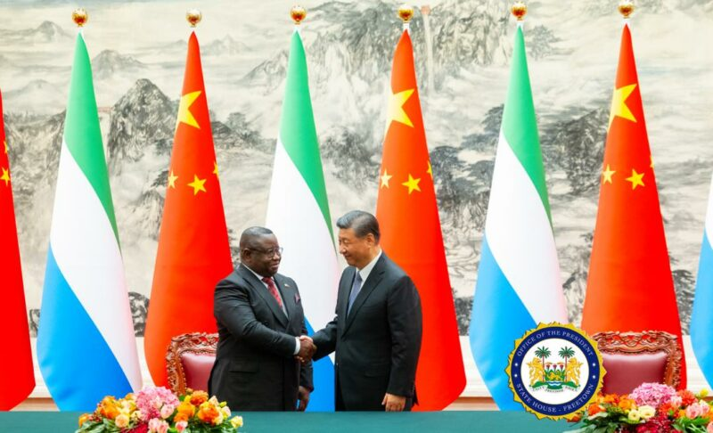

President Xi Jinping of China has declared a comprehensive $9 million financial and technical aid package for Sierra Leone. The announcement, made during talks with Sierra Leone’s President Julius Maada Bio, who is on a mission to secure substantial economic aid and investments, aims to bolster the West African nation's struggling economy.

**Boosting Economic Ties Amidst Controversy**

The announcement follows closely on the heels of a controversy involving a Chinese investment group seeking a drastic increase in toll gate fees, sparking widespread criticism among Sierra Leoneans. President Bio, during his visit to Beijing, is seeking a more substantial economic aid and investment package, potentially worth hundreds of millions of dollars, to provide much-needed stimulus to Sierra Leone's economy.

**China's Financial Package Unveiled**

China's financial package unveiled yesterday comprises $6.9 million in economic and technical assistance, $2.7 million in debt cancellation, and an additional 1500 tonnes of food assistance. However, there is uncertainty regarding the actual cash component of the $6.9 million, raising questions about its immediate impact on alleviating Sierra Leoneans' economic struggles.

**Long-standing Partnership and Mutual Commitments**

In a statement from State House, President Xi Jinping acknowledged President Bio as the first African Head of State to be received in 2024, emphasizing the efficient cooperation between Sierra Leone and China. President Xi Jinping highlighted China's ongoing support for Sierra Leone's big five priorities and praised President Bio's leadership of the African Union’s C-10. He extended an invitation to President Bio to attend the upcoming Forum on China-Africa Cooperation Summit, citing the longstanding and exemplary nature of the Africa-China relationship.

**Expressions of Gratitude and Assurance**

President Bio expressed gratitude for China's economic and technical assistance, debt cancellation, and food aid. He noted the enduring bond between the two nations dating back to 1971 and thanked President Xi Jinping for China's support during the UN Security Council elections. President Bio assured China of Sierra Leone's commitment to resolutions promoting global peace and security.

**Deepening Bilateral Ties**

In his remarks, President Bio stated, "China has been a reliable partner of Sierra Leone. It is my conviction that this visit will deepen the bilateral relationship between Sierra Leone and China." As Sierra Leone navigates economic challenges, the aid package from China holds the potential to reshape the economic landscape and strengthen diplomatic ties between the two nations.

**LEAD THREE**

**Will EBK’s Treason Trial Continue?**

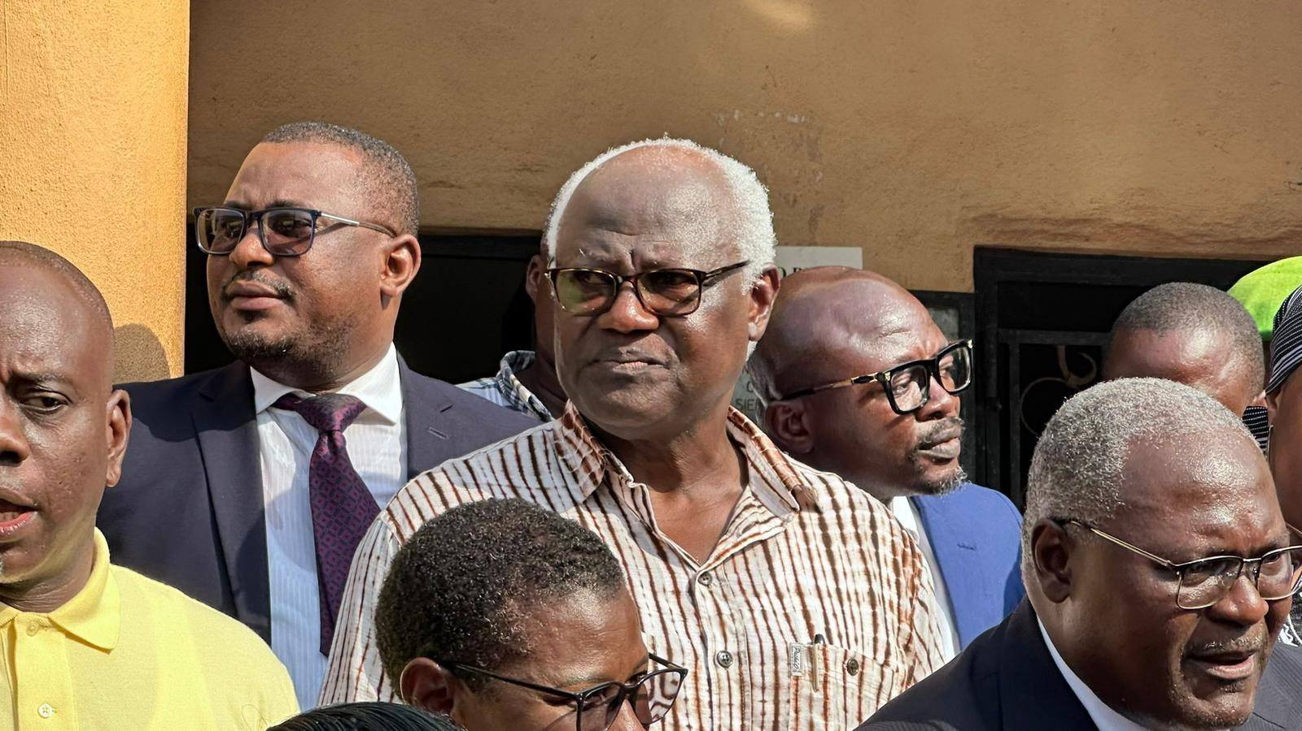

One of the most asked questions on the streets is,will the treason trial of Former President Ernest Bai Koroma continue as planned on Wednesday, March 6, 2024? The anticipation hangs thick in the air, intensified by a two-month adjournment since January.

Facing a four-count charge connected to his alleged involvement in the government overthrow on November 26, 2023, Koroma stands accused of treason, misprision of treason, and harboring. His legal team vehemently rejects these charges, branding them a "dangerous precedent" that casts a dark shadow over the nation.

Lead Counsel Joseph Kamara boldly defends the former president, portraying the allegations as part of a political vendetta that could set a perilous precedent for dragging a democratically elected head of state into such controversies.

Judge Samuel O. Taylor, responding to these weighty accusations, granted bail to Koroma under specified conditions. The conditions include restrictions on the number of individuals at Koroma's residence, limiting it to his wife, children, lawyers, and political party members, to a maximum of 10 people at any given time. Furthermore, the former President is tethered to his residence, unable to leave without explicit permission from the Inspector-General of Police.

In a surprising turn, on January 17, Koroma received authorization to leave Sierra Leone for urgent medical treatment, following a successful bail review application. Justice S.O. Taylor, who had initially examined and approved the bail conditions, allowed the former President, currently facing serious charges, to seek medical attention abroad for ninety days. Subsequently, Koroma sought medical treatment in Nigeria.

Yet, a cloud of uncertainty now shrouds the upcoming court appearance. Will the wheels of justice turn as scheduled, or will the trial be further delayed due to the former president's current medical absence? The nation watches and contemplates the delicate balance between justice and a leader's health, pondering the implications of a trial that hangs in the balance of political intrigue and personal well-being.

**U.S. Military Advisors Elevate Sierra Leone Armed Forces through Critical Site and Asset Security Training**

**[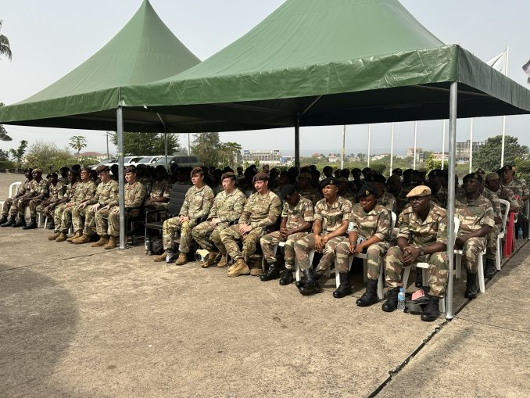](https://i0.wp.com/www.thesierraleonetelegraph.com/wp-content/uploads/2024/03/U.S.-military-advisors-train-Sierra-Leone-armed-forces-on-critical-site-and-asset-security-2-e1709500014479.jpg?ssl=1)**

In a significant stride towards fortifying national security, the United States Army Security Force Assistance Brigade lauded the achievements of 80 Republic of Sierra Leone Armed Forces (RSLAF) soldiers, ranging from Lance Corporals to Warrant Officer 1, on Friday, 23rd February 2024. This commendation followed the successful completion of a rigorous three-week training program focusing on critical site and asset security.

The training initiative stemmed from the alleged security breach at Wilberforce, Freetown, last September. The incident involved an attack on the nation's primary ammunition stores, resulting in the theft of weapons purportedly used in an attempted coup. In response, the U.S. Embassy in Freetown revealed that the Security Force Assistance Brigade, a specialized unit with the core mission of advising and assisting partner nations in enhancing their threat-response capabilities, conducted the training.

In a statement, the Embassy highlighted the commitment of both nations to democratic and human rights norms. It emphasized the Security Force Assistance Brigade's role in aiding the RSLAF in the modernization and professional development of its forces. The intensive three-week program targeted defense technical skills, covering areas such as perimeter patrol, critical site and asset security, and entrance and access control points.

The training not only augmented existing RSLAF protocols but also facilitated knowledge exchange and professional development opportunities for both U.S. Army and RSLAF personnel. This partnership signifies a crucial milestone in bilateral cooperation, contributing to Sierra Leone's defensive capabilities while reinforcing professionalism, respect for human rights, and adherence to democratic norms within the RSLAF.

The collaboration between the United States and Sierra Leone is viewed as a pivotal step toward enhancing regional security and stability. The commitment reiterated in the statement affirms the United States' dedication to supporting Sierra Leone's journey towards democracy, health, and prosperity. The collaborative efforts aim to build a strong partnership that mutually benefits both nations.