**LEAD ONE**

**SLPP/NGC Alliance Crumbles**

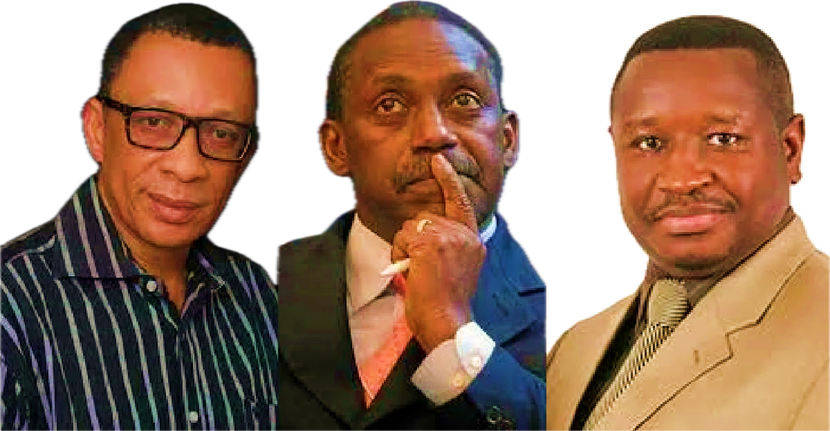

Chaos erupted at the most recent National Executive Committee (NEC) meeting of the National Grand Coalition Party (NGC). This is in direct response to a faction within the party, vehemently advocating for a divorce from the SLPP alliance, faced off against opposing members, setting the stage for a volatile showdown.

The meeting, intended to be a crucial moment in the NGC's history, witnessed an unexpected twist as the Sierra Leone Police stepped in to disperse the conflicting groups. The air crackled with tension as accusations flew, with one side arguing for immediate withdrawal and the other asserting that only the National Delegate Conference (NDC) had the constitutional authority to make such decisions.

Amid the chaos, the NGC grapples with internal strife intensified by the departure of one of its founders, the Former Member of Parliament and NGC leader, Kandeh Kolleh Yumkella. Yumkella's exit has cast a shadow over the party, leaving it at a crossroads.

The Sierra Leone Police, in response to the escalating situation, issued a statement confirming that they had received a request for security coverage for the contentious NEC meeting. The letter, sent by the NGC National Secretary General, hinted at potential disruptions fueled by differences in opinion, escalating tensions and the looming specter of violence.

As the meeting unfolded at the NGC headquarters, located at 14 Naimbana Street, Freetown, the anticipated clashes became a reality. Both verbal and physical confrontations erupted, prompting the police to intervene and bring an uneasy peace to the tumultuous gathering.

Notably, no arrests were made during the police intervention. The NGC now faces an uncertain future, with internal divisions laid bare and the fate of its alliance with the SLPP hanging in the balance.

**LEAD TWO**

**National Pentecostal Mission SL Marks Historic Foundation Day with 1st Grand Combined Service**

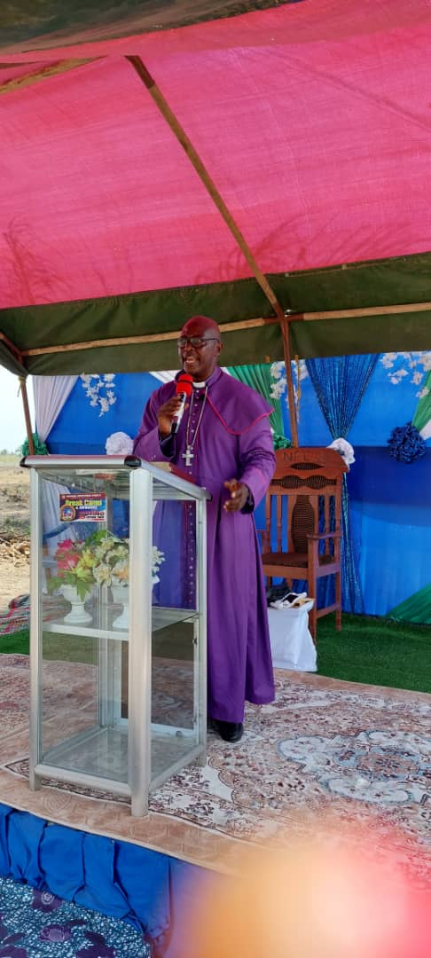

In a monumental celebration of its foundation day and a significant milestone in its expansion initiative, the National Pentecostal Mission Sierra Leone convened its first combined service at the newly acquired location in Songo, situated in the Northern Province of the Republic of Sierra Leone. The event, marked by fervent prayers, inspirational speeches and a jubilant atmosphere, drew a distinguished gathering of government dignitaries, Members of Parliament, the Section Chief, Headmen of Songo, and religious leaders from various churches in Freetown and beyond.

Reverend Sarah K. Kanu, with genuine enthusiasm, welcomed the esteemed guests and members of the National Pentecostal Mission Sierra Leone. She deemed the occasion historic, expressing her heartfelt appreciation for everyone who participated in the foundation day celebration at the new site in Songo. Reverend Kanu extended gratitude to past and present leaders of the mission for their unwavering commitment to securing the land, acknowledging their immense contributions to the expansion of God's work in Songo.

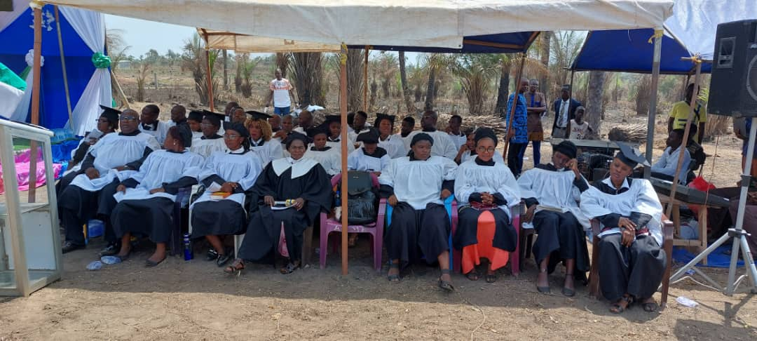

Bishop Emeritus Tamba A. Koroma, the former Bishop of the National Pentecostal Mission Sierra Leone, commenced the proceedings with opening remarks and offered prayers of thanksgiving for the entire membership of the mission and the new site at Songo. He lauded his successor, Bishop Benjamin B. Bangura, for his hard work and dedication to the mission's growth and development. Bishop Koroma passionately urged all members to steadfastly support Bishop Benjamin Bangura's vision and aspirations, emphasizing the importance of unity in realizing the mission's goals.

Superintended Mrs. Mary S. Kamara, after reading from the Old Testament, delivered words of encouragement, urging all present to actively support the ambitious project of building the house of God in Songo. Despite acknowledging the magnitude of the undertaking, she reassured attendees that with faith, there is nothing too challenging for God. Mrs. Kamara called for collective prayers for the leadership, especially Bishop Benjamin Bangura, seeking God's continued guidance and protection.

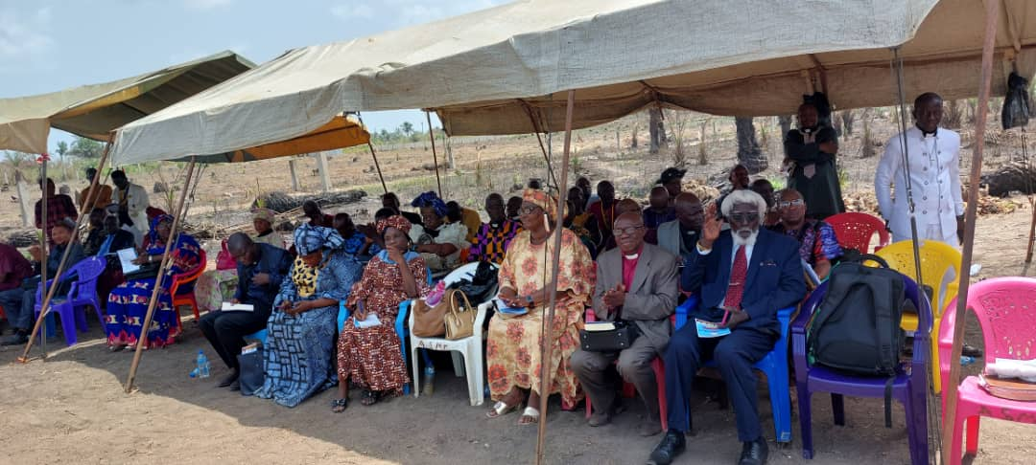

Bishop Benjamin Bangura, the head of the National Pentecostal Mission Sierra Leone, expressed profound gratitude to the Almighty God for steering the mission through another foundation day celebration. Overwhelmed with joy, he shared his elation at the growth and expansion of the mission, describing the acquisition of land in Songo as a divine blessing.

In a spirited address, Bishop Bangura conveyed his appreciation to Bishop Emeritus Tamba A. Koroma for his leadership and pledged to fulfill the responsibilities entrusted to him. He urged members to place unwavering trust and confidence in God, emphasizing the divine significance of the land in Songo.

“Words cannot express enough how it feels that the land we occupy in Songo belongs to the National Pentecostal Mission Sierra Leone,” Bishop Bangura stated.

In a jubilant moment, Bishop Bangura announced the dedication of the land to the Almighty God, declaring it a testament to the mission's achievements as they celebrated their foundation day.

LEAD THREE

**Potential Legitimacy Concerns**

**Surrounding USL Degrees**

**By: Christian Conteh**

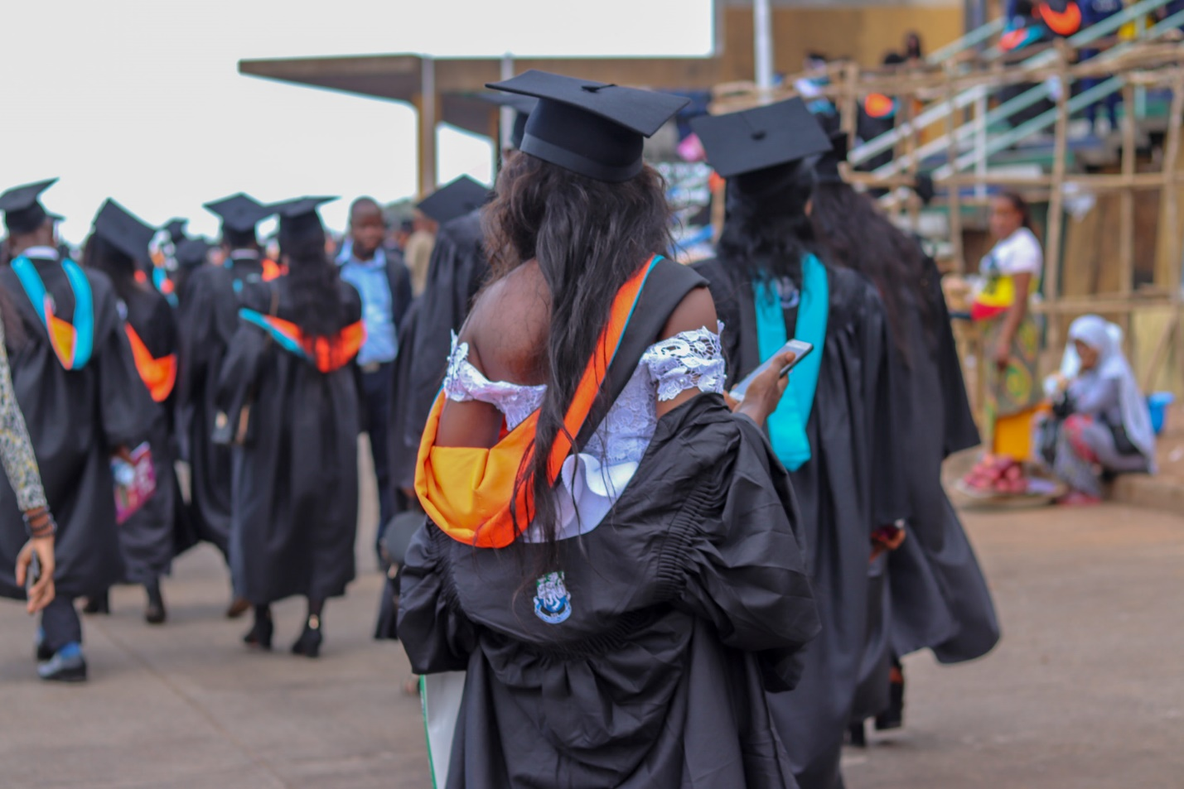

Recent developments in Sierra Leone's education landscape particularly the ongoing saga between the Higher Education Minister Dr. Haja Ramatulai Wurie and the structures within the University of Sierra Leone (USL) haveraised significant questions about the legality of degrees that may be awarded by the USL. The concerns stem from a lack of clarity and adherence to crucial provisions within the legislation.

One of the critical components defining the authority structure of a university is outlined in Section 5 of the University Act. The authorities listed, including the Chancellor, Vice-Chancellor and Principal, Pro Vice-Chancellor, Deputy Vice-Chancellor, the Court and the Senate form the backbone of the university's decision-making and operational framework.

However, a statement from the Minister of Tertiary and Higher Education, Dr. Haja Ramatulie Wurie, reveals a potential gap in the implementation of the University Act. Dr. Wurie pointed out that her role in appointing an acting Vice Chancellor (a position that is not provided for by law) and Principal would not have been necessary if there were a Pro Vice Chancellor in place. She placed blame on the dissolved University Court, asserting that they failed in their mandate to appoint the Pro Vice Chancellor, as stipulated in the Universities Act 2021.

The crux of the matter lies in the absence of a functioning university court with the authority to preside over congregations. This omission raises concerns about the degrees' legitimacy, as they may not be awarded by the competent authority, potentially leading to legality issues.

Section 46 of the University Act specifically addresses congregations, the formal gatherings necessary for conferring degrees and other academic awards. However, the lack of a properly constituted University Court, which should preside over congregations, adds a layer of uncertainty to the entire degree conferment process.

According to Section 46(1), a Congregation should be held under the auspices of the Court, emphasizing its pivotal role in the legitimacy of academic awards. The absence of this authoritative body could compromise the validity of degrees conferred by the university.

Furthermore, Section 46(3) outlines the hierarchy of officials who can preside over a Congregation. In the absence of the Chancellor, the Vice-Chancellor and Principal should preside, followed by the Pro Vice-Chancellor and then a Deputy Vice-Chancellor nominated by the Court. If the University Court is not properly constituted, questions arise regarding the legitimacy of the individual presiding over the Congregation.

The lack of a clear procedure for summoning a Congregation, as mentioned in Section 46(4), further adds to the uncertainty surrounding the awarding of degrees by the University of Sierra Leone.

In light of these legal ambiguities, stakeholders and the public must seek clarification from relevant authorities to ensure the integrity of academic degrees conferred by the University of Sierra Leone.

Addressing these concerns is crucial to upholding the reputation and credibility of the educational institutions in Sierra Leone and ensuring that students' hard-earned qualifications are recognized and respected on a global scale.

**LEAD FOUR**

**Africell and UN Women Call for Inclusivity on International Women's Day**

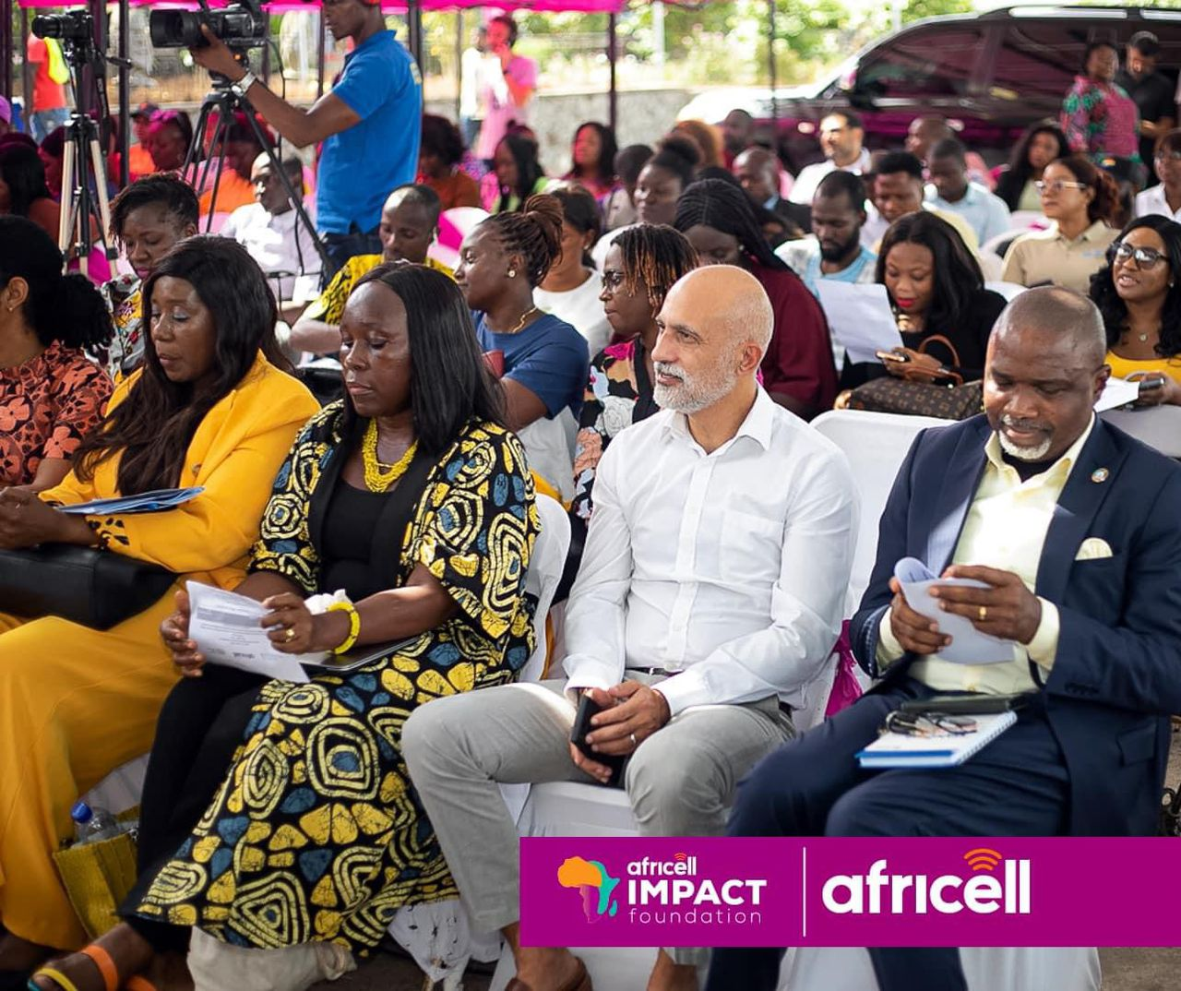

In a remarkable celebration of diversity and empowerment, Africell Impact Foundation, in partnership with UN Women, marked International Women's Day with a resounding call for inclusivity in the workplace. Under the theme "Inspiring Inclusion in the Workplace," the event took place at Africell's headquarters in Wilberforce, Freetown, echoing the global mission to promote gender equality and women's rights.

The event served as a platform to recognize the invaluable contributions of women to society and advocate for greater representation and participation in all spheres of life, particularly within the corporate world. With engaging discussions, insightful panels, and inspiring speeches, participants explored strategies to break down barriers and foster a culture of inclusivity in workplaces across Sierra Leone.

Keynote speakers highlighted the importance of creating environments where women feel empowered to thrive, emphasizing the need for policies and initiatives that promote gender balance, equal opportunities, and support for career advancement. They underscored the transformative impact of diverse perspectives and experiences in driving innovation and sustainable development.

One of the highlights of the event was the unveiling of initiatives by Africell Impact Foundation and UN Women aimed at advancing women's economic empowerment and leadership opportunities. These initiatives include mentorship programs, skills development workshops, and advocacy campaigns to address gender-based discrimination and promote inclusive practices in recruitment and promotion processes.

Participants also had the opportunity to engage in networking sessions and connect with like-minded individuals committed to championing gender equality and women's rights. The event served as a catalyst for ongoing collaboration and collective action to create a more inclusive and equitable society for all.

In his closing remarks, Africell's Managing Director Shadi Gerhawi reiterated the company's commitment to diversity and inclusion, reaffirming their dedication to creating a workplace where every individual, regardless of gender, feels valued, respected, and empowered to reach their full potential.

As the world commemorates International Women's Day, the collaboration between Africell Impact Foundation and UN Women stands as a testament to the power of partnership in driving meaningful change. By inspiring inclusion in the workplace, they are paving the way for a brighter, more equitable future for women in Sierra Leone and beyond.

**Global Gender Gap Exceeds Previous Estimates, Hindering Women's Economic Empowerment**

**Bottom Strap**

***World Bank ‘Women, Business and the Law 2024’ Report***

**By: Christian Conteh**

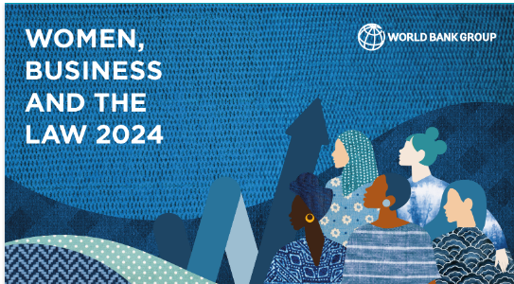

A 2024 report released by the World Bank Group has revealed that the global gender gap in the workplace is more extensive than previously believed, with women enjoying only two-thirds of the legal rights afforded to men. The latest edition of the Women, Business, and the Law report expands its analysis to include critical factors such as safety from violence and access to childcare, showcasing a stark picture of the obstacles women face worldwide.

When considering legal differences involving violence and childcare, women, on average, possess just 64% of the legal protections that men do, a significant drop from the previous estimate of 77%. The report emphasizes that no country, including the wealthiest economies, offers equal opportunities for women.

A notable aspect of the report is the assessment of the implementation gap between legal reforms and actual outcomes for women in 190 economies. Despite laws implying that women enjoy roughly two-thirds of men's rights, the study exposes that countries have established less than 40% of the necessary systems for full implementation.

Chief Economist of the World Bank Group, Indermit Gill, underscores the potential economic impact of closing the gender gap: ***"Women have the power to turbocharge the sputtering global economy."*** Gill highlights the need for strong enforcement mechanisms, pay transparency measures, and healthcare services for survivors of violence to effectively implement equal-opportunity laws.

The report reveals Togo as a standout in Sub-Saharan economies, providing women with approximately 77% of the rights available to men. However, the country has only established 27% of the systems necessary for full implementation, representing an average scenario for Sub-Saharan economies.

In 2023, governments made strides in advancing legal equal-opportunity reforms in pay, parental rights, and workplace protections. However, the report identifies poor performance in the new categories of access to childcare and women's safety.

Women's safety emerges as a critical concern, with a global average score of just 36, indicating that women barely enjoy a third of the needed legal protections against domestic violence, sexual harassment, child marriage, and femicide. Additionally, inadequate laws on sexual harassment in public spaces hinder women's use of public transportation.

Childcare laws also receive low scores, with only 78 economies providing financial or tax support for parents and 62 having quality standards for childcare services. Expanding access to childcare is crucial for increasing women's participation in the labor force.

The report highlights obstacles in entrepreneurship, where only one in five economies mandates gender-sensitive criteria for public procurement processes, limiting women's access to a $10-trillion-a-year economic opportunity. In terms of pay, women earn just 77 cents for every $1 paid to men, and discrepancies extend to retirement, affecting women's financial security in old age.

Lead author Tea Trumbic emphasizes the urgency of reforming laws and enacting policies to empower women economically. Trumbic states, ***"Countries simply cannot afford to sideline half of their population,"*** pointing out that increasing women's economic participation is essential for shaping decisions that affect them directly.